**CSE523 Machine Learning**

**Prof. Mehul Raval**

**Anomaly detection in computer networks to identify unusual activity or potential security threats**

**Week 7 Report**

| **Name** | **Enrolment Number** |
| --- | --- |
| Vatsal Patel | AU2040043 |
| Shreya Karia | AU2040076 |
| Digant Patel | AU2040086 |
| Samarth Chauhan | AU2040097 |

For this week, we implemented the Quadratic Discriminant Analysis algorithm for our classification problem. The algorithm was executed first without PCA then with PCA to observe the difference.

Results without PCA:

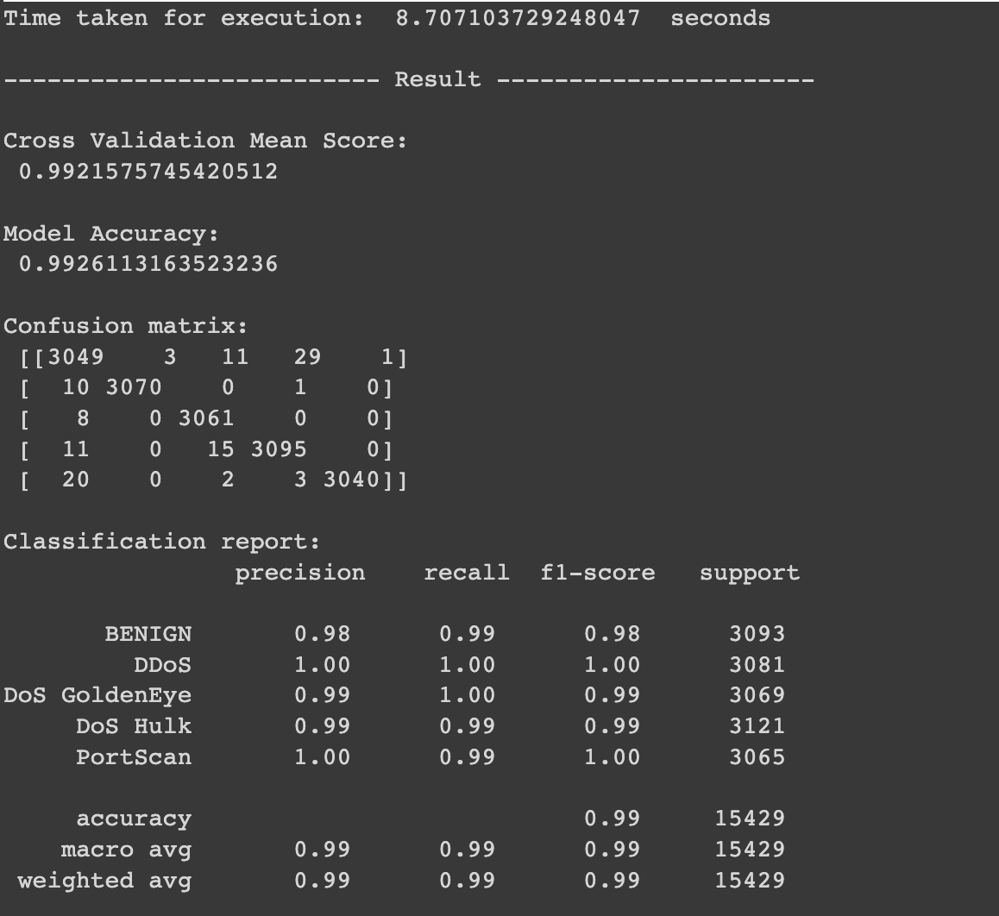

After applying PCA with 30 features:

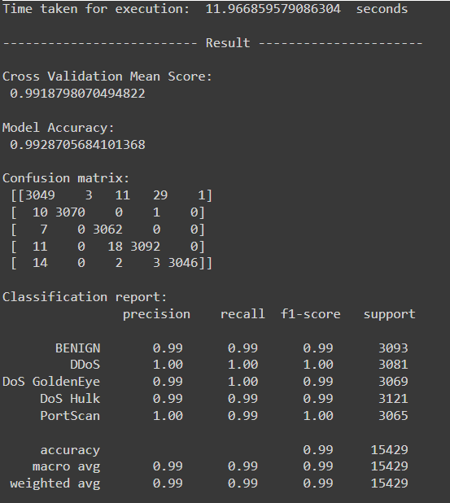

We’ve now determined that if we want to speed up the training of our model PCA is the best method for Dimensionality reduction. It maintains or increases the accuracy of the model and decreases the runtime.

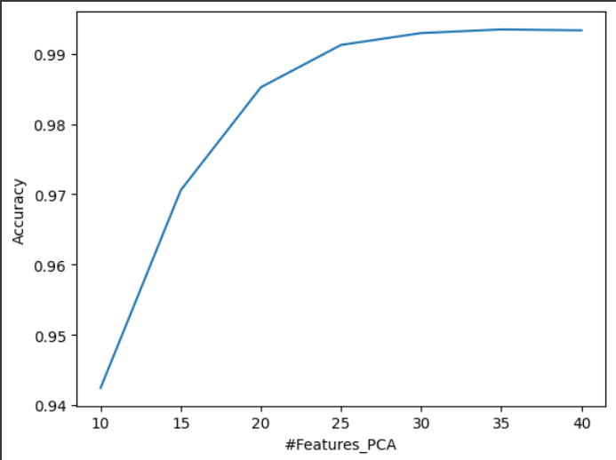

If we apply PCA to a QDA algorithm with features less than 10 the accuracy gets affected severely so the most efficient QDA implementation is by applying PCA with more than 25 features for the Quadratic Discriminant Analysis algorithm.

PCA in lower dimensional space may lead to loss of information and thus can be attributed to the accuracy being severely affected with features less than 10. But for more than that we can see that there is gradual increase in accuracy from 10 to 25 features and then it stabilizes. Since, initially there are 41 columns, and after PCA we can see that 40 features give one of the optimal results, PCA may not be required in the case of QDA. This is because of two primary reasons, there no significant improvement in accuracy or time taken to train the model.

PCA captures the linear relationship between the data, whereas QDA models complex non-linear relationship between the classes and the features. So, PCA may hinder in the working of QDA, because it works by using quadratic functions to model class-conditional probabilities.

Another point to consider is that for QDA, the covariance structure of each class is important for classification, but PCA takes in account the principal components which capture most variance without considering the different classes. This can also be attributed to reduced accuracy.